Local RAG Assistant Project Report
1. Introduction
Artificial Intelligence applications often rely on Large Language Models (LLMs) to answer user questions. However, these models may generate incorrect or fabricated information when the required knowledge is unavailable. Retrieval-Augmented Generation (RAG) addresses this problem by retrieving relevant information from a document collection before generating a response.
The aim of this project is to develop a simple Local RAG Assistant that retrieves information from local Word documents and answers user questions using Microsoft Foundry Local. The system runs entirely on the user's computer without requiring cloud-based services.
2. Project Objectives
The main objectives of this project are:
- Build a fully local RAG pipeline
- Store document embeddings in SQLite
- Retrieve relevant document chunks using semantic search
- Generate answers using a local LLM
- Prevent hallucinations by restricting answers to retrieved documents
- Evaluate the system through functional testing
3. Technologies Used
Technology | Purpose
Python | Main programming language
Microsoft Foundry Local | Local LLM runtime
Sentence Transformers | Embedding generation
SQLite | Local database
NumPy | Similarity calculations
python-docx | Reading Word documents
4. System Architecture
The system consists of four main components:
- Document Ingestion
Word documents stored in the resources folder are read and converted into text.
- Embedding Generation
Each document is divided into overlapping chunks. Embeddings are generated using the intfloat/multilingual-e5-base model.
- Retrieval
When the user asks a question, the question is embedded and compared with all stored document embeddings using cosine similarity. The most relevant chunks are selected.
- Response Generation
The retrieved chunks are sent to a local LLM running with Microsoft Foundry Local. The model generates an answer using only the provided context.
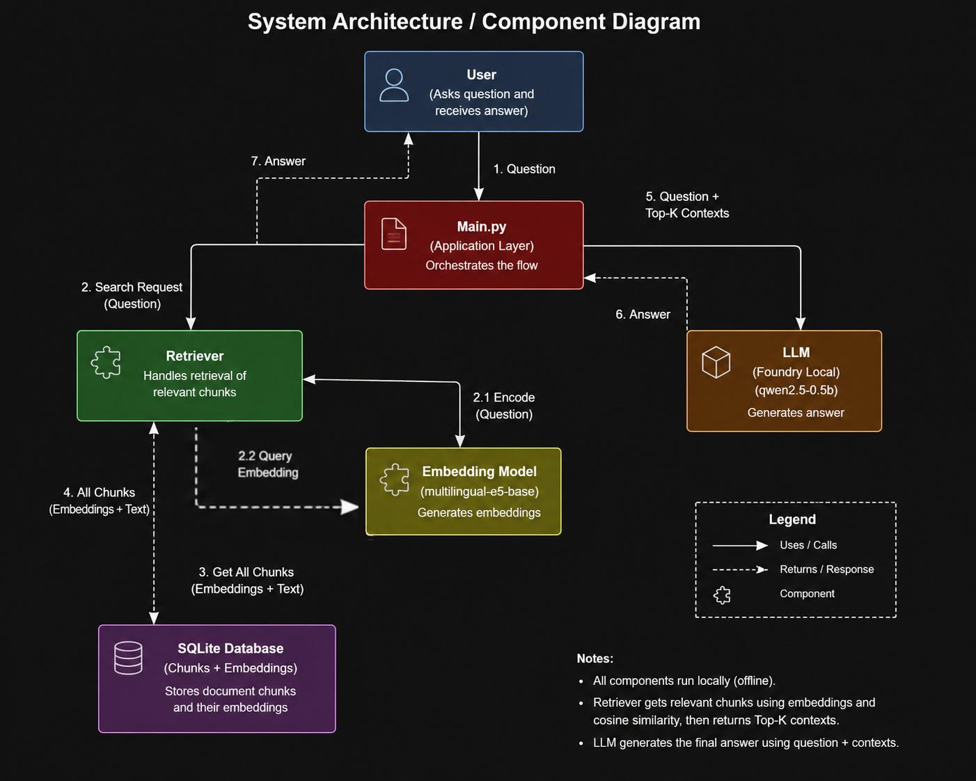
5. Project Workflow
The overall workflow of the Local RAG Assistant consists of the following steps:
- Load Documents
  - Word documents are read from the resources folder.
- Create Chunks
  - Each document is divided into overlapping text chunks (600 characters with 200-character overlap).
- Generate Embeddings
  - An embedding vector is created for each chunk using the intfloat/multilingual-e5-base model.
- Store Data
  - Chunks and their embeddings are stored in the local SQLite database.
- Receive User Question
  - The user enters a question through the command-line interface.
- Embed the Question
  - The user's question is converted into an embedding vector using the same embedding model.
- Retrieve Relevant Chunks
  - Cosine Similarity is used to compare the question embedding with stored document embeddings, and the Top-K most relevant chunks are selected.
- Generate Response
  - The retrieved chunks are sent to the local LLM through Microsoft Foundry Local to generate the final answer.
- Sequence Diagram:
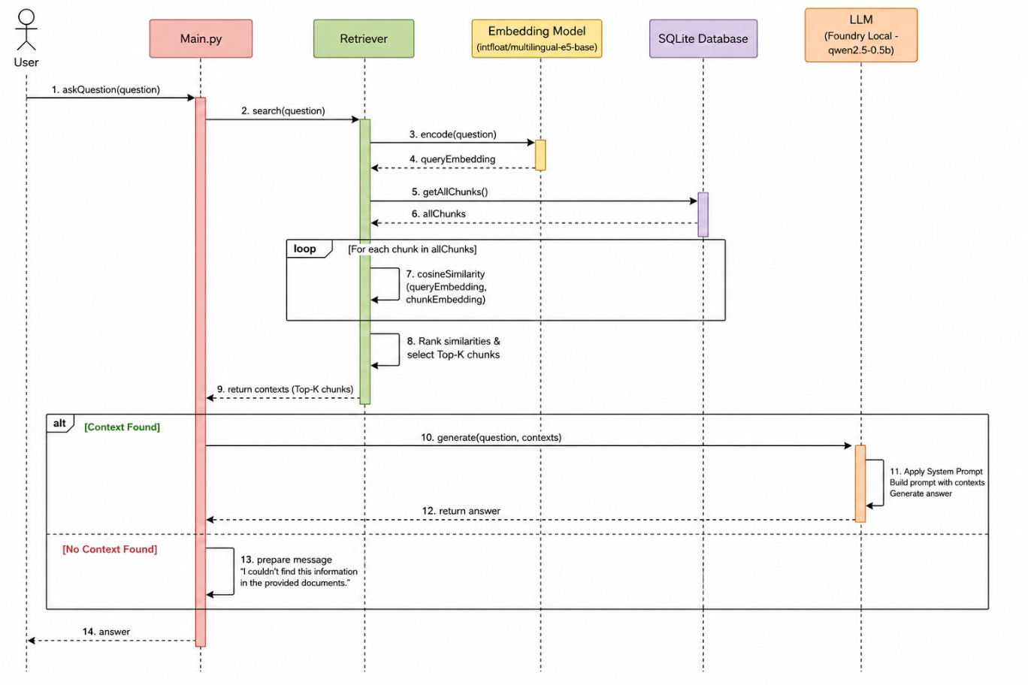
6. Implementation
The project consists of several Python modules.
File | Description
config.py | Stores project configuration
database.py | Handles SQLite operations
ingest.py | Reads documents and creates embeddings
retriever.py | Performs semantic retrieval
llm.py | Communicates with Foundry Local
main.py | Main application
tests.py | Runs functional tests
7. Testing
The system was evaluated using 15 functional test cases.
The tests include:
- Questions that exist in the documents
- Questions outside the knowledge base
- Retrieval accuracy
- Fallback response validation
All test cases passed successfully.

8. Results
The developed assistant successfully retrieves relevant document chunks and generates responses based only on the retrieved context.
The use of semantic embeddings improves retrieval quality compared to keyword-based search, while Microsoft Foundry Local enables completely offline inference.
The evaluation also showed that the fallback mechanism successfully prevents the model from generating answers when the requested information is unavailable.
9. Limitations
The current implementation has several limitations:
- Only Word (docx) documents are supported.
- SQLite performs a brute-force similarity search.
- The system is limited to command-line interaction.
- Retrieval quality depends on chunk size and embedding quality.
10. Future Improvements
Possible future improvements include:
- Support PDF and TXT documents.
- Replace SQLite with a vector database.
- Add metadata-based retrieval.
- Develop a graphical user interface.
- Improve retrieval efficiency for larger document collections.
11. Conclusion
This project demonstrates how a Retrieval-Augmented Generation system can be implemented entirely on local hardware. By combining semantic search, SQLite, Microsoft Foundry Local, and a local language model, the assistant provides reliable document-based answers while reducing hallucinations. The completed implementation satisfies the project objectives and serves as a foundation for more advanced local AI applications.

